Music and Stitch

Music is a very important aspect in my life; I enjoy music in many forms and variations, no matter if it is recorded (CD’s, online etc) or live music, concerts, gigs, making music with friends.

I enjoy listing to music while I work with my hands , at home or when I am out at concerts or local music events.

I am known for taking knitting/stitching along with me, wherever I go.

The initial idea to link music with my Stitching Project, came through a visit to the local St. Mary’s church. The atmosphere, up on the balcony by the window, was the first place where I was filmed while stitching. Nigel Wicken, a friend of mine, is the organist of this church and we experimented with music and did some recording.
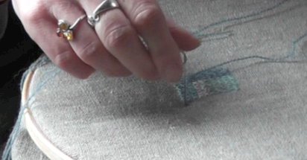
Stitching at the Church

In this situation the music was a beautiful piece by Arvo Paert - “Mirror in the mirror”.
A very beautiful, serene atmosphere was created. Something was missing. There was a distance between the setting by the window and the musician at the organ. A beginning, but not quite the dialogue I was looking for.

The next collaboration happened with Bill Goodyear in his flat. Bill improvised on his guitar while being aware of my presence. I was listing to him, while stitching. In the film and photography the dialogue is not visible.
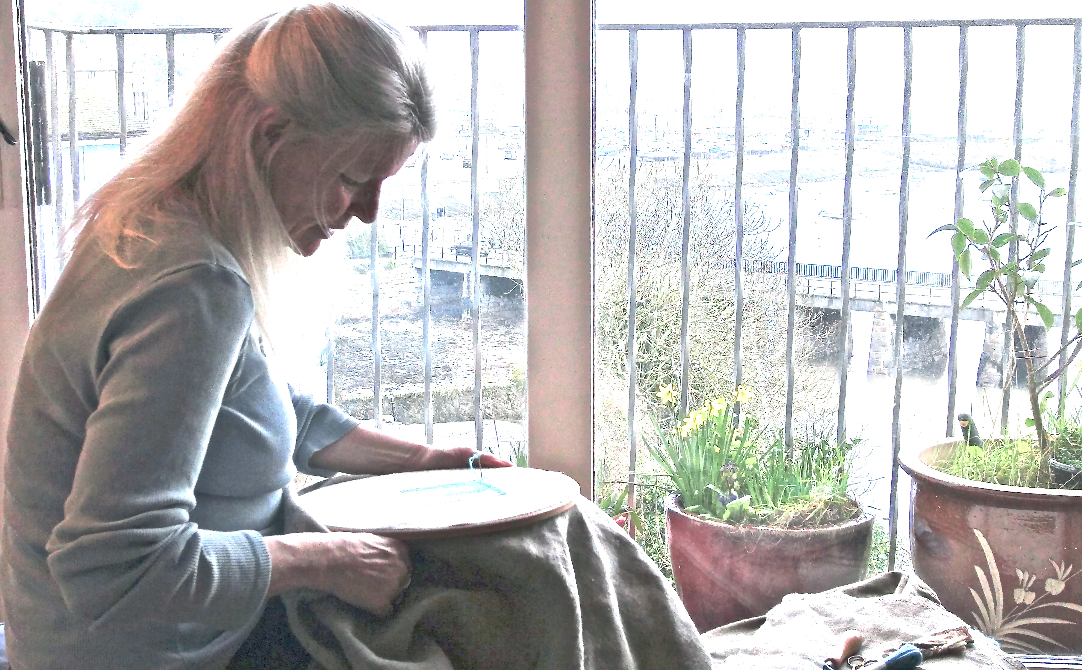
At Bill’s flat

We both enjoyed the experience and the next step was to go outside to Mousehole Beach.
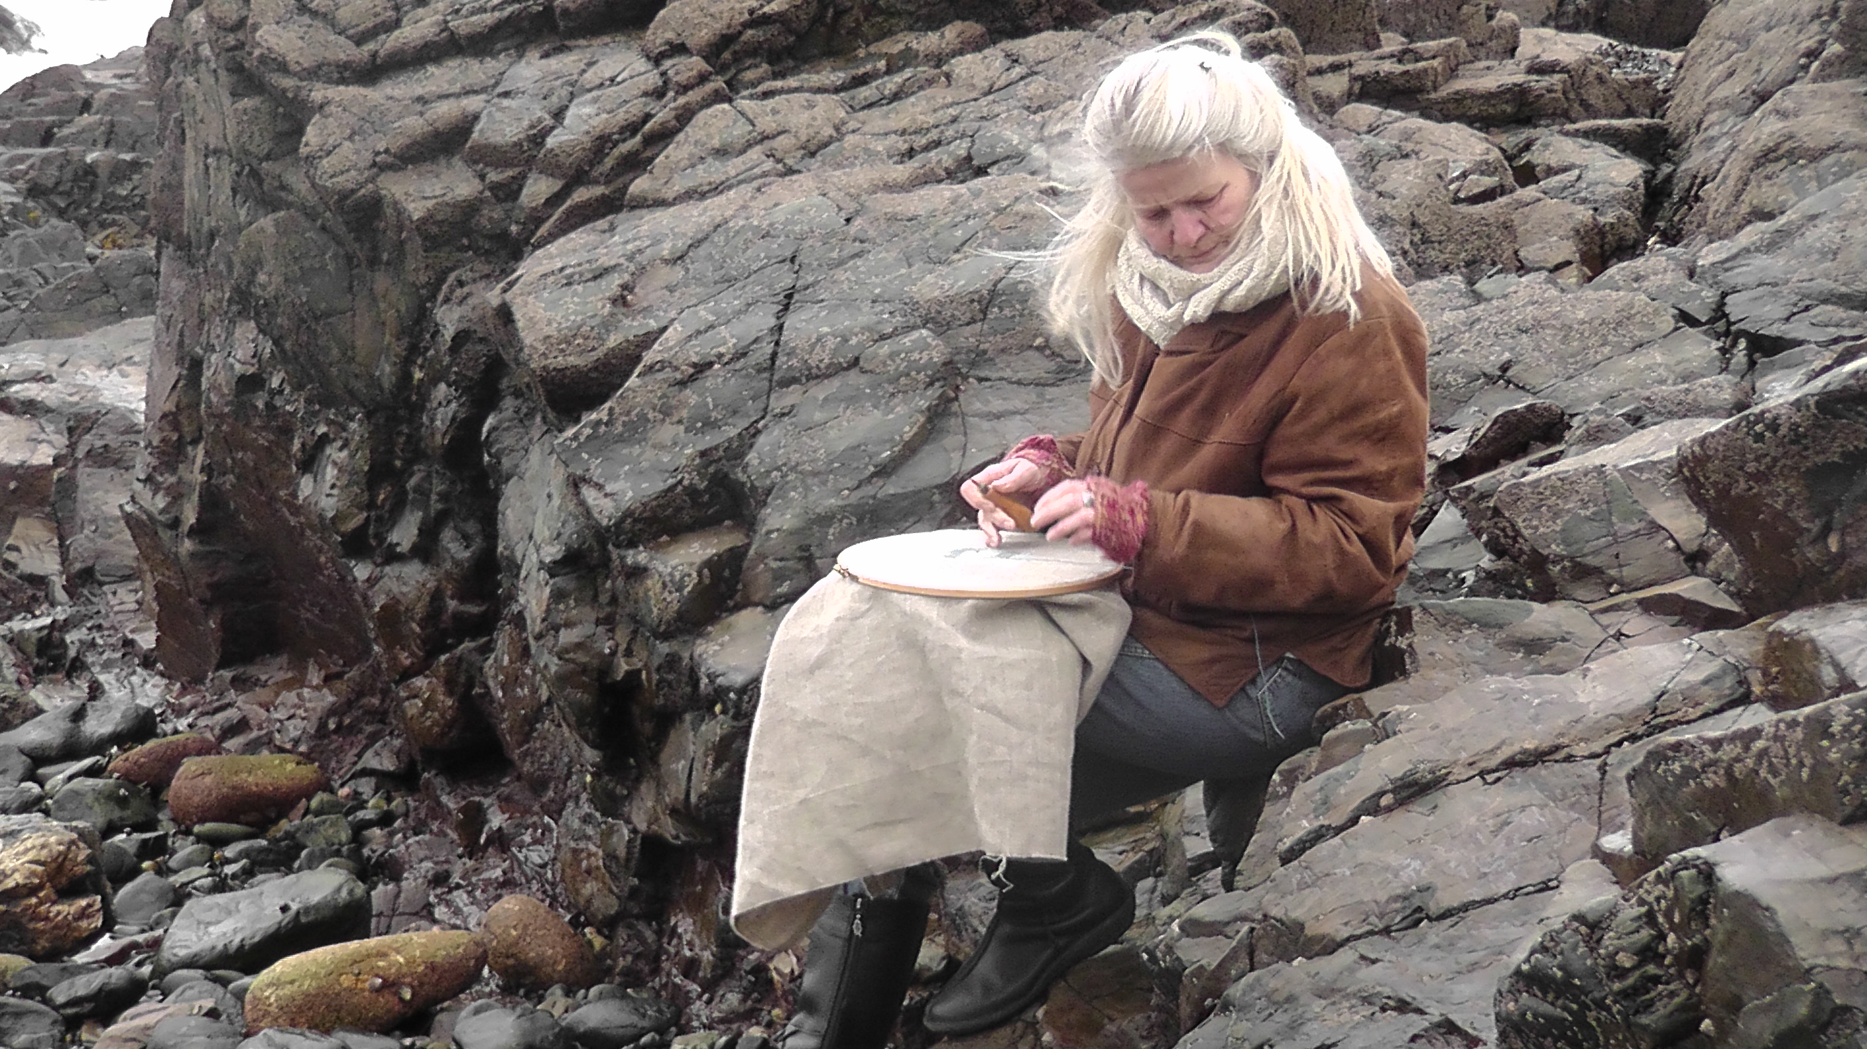
Mousehole Beach

But still the music was not “visible”.

Only when I went out with Jamie and suddenly had the idea of us sitting together the quiet dialogues became visible.

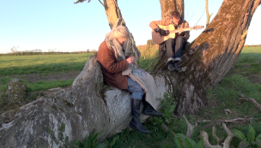
Jamie Mills and me in the Field

After this evening it became clear to me that I wanted to show the dialogue, the collaboration, in my documentation.

Bill and I spent some time at Priest Cove, St. Just and sat together, playing and stitching, it felt just like a beginning. Bill said afterwards, he felt like weaving in and out from being ‘lost’ in his music and the awareness of my presence. In a subtle way he follow my movement.

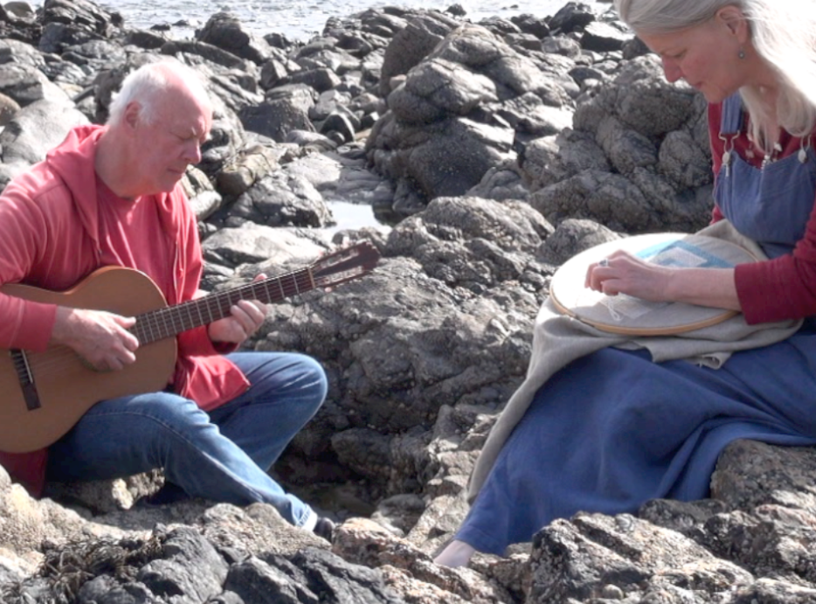
Bill Goodyear at Priest Cove

Another meeting was with Ruth Bolton and her three daughters, Jessie, Iris and Amy.

The youngest one preferred to be behind the camera: it was a wonderful experience how the flute (Jessie), the cello (Iris) and the violin (Ruth) wove together with my Stitching.
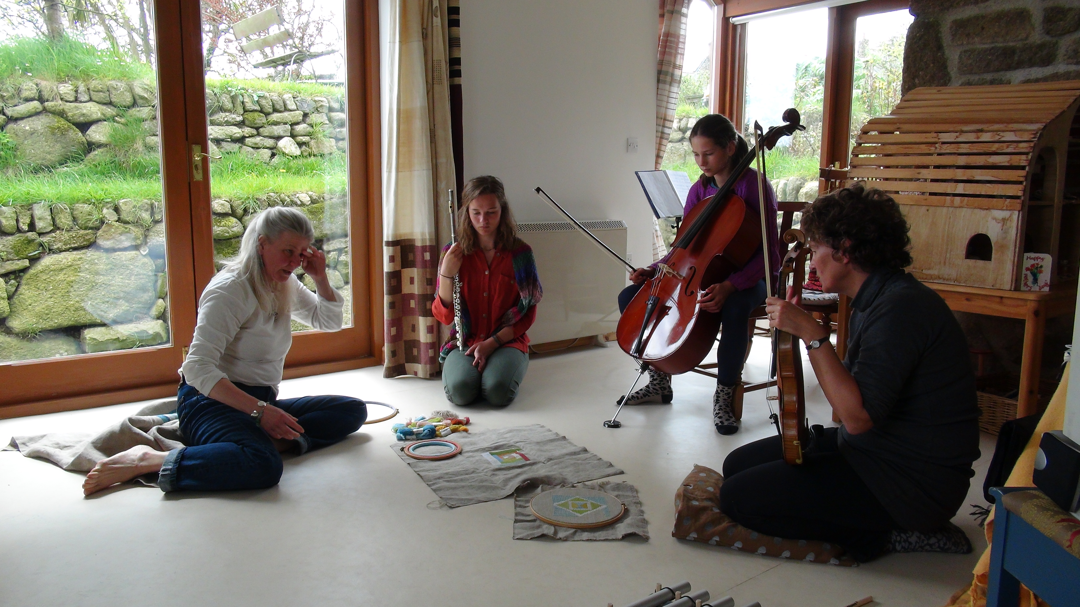
Ruth, Jessie and Iris Bolton

After this afternoon, I came to realise that I want to start a further exploration into a dialogue between Music and Stitch.
The next step would be to start a new piece of cloth and respond to the music with the Stitches.

